**Name: Pushkar Sutar**

**Roll No.: 2019110060**

**Batch: A**

**Course Code : Minors Web Technology**

**Experiment No.:2**

**Name of the Experiment : Creating form with validation.**

**Create an abc company ecommerce website which has 4 menus (About us, Products, Team members, Feedback form).Feedback form should consist of following fields:Name of the person, email, contact, address, Complaint in paragraph, Upload the image(if any) and submit button. The form should be validated for contact number and email address.**

**Theory :**

1. **List the tags used in html file along with its meaning in 2-3 lines.**- html : The <html> tag represents the root of an HTML document. The <html> tag is the container for all other HTML element.- head : The <head> element is a container for metadata (data about data) and is placed between the <html> tag and the <body> tag.  
   - link : The <link> tag defines the relationship between the current document and an external resource.  
   - title : The <title> tag defines the title of the document. The title must be text-only, and it is shown in the browser's title bar or in the page's tab.  
   - meta : The <meta> tag defines metadata about an HTML document. Metadata is data (information) about data.  
   - body : The <body> element contains all the contents of an HTML document, such as headings, paragraphs, images, hyperlinks, tables, lists, etc.  
   - div : The <div> tag defines a division or a section in an HTML document.  
   - form : The <form> tag is used to create an HTML form for user input.  
   - table : The <table> tag defines an HTML table. An HTML table consists of one <table> element and one or more [<tr>](https://www.w3schools.com/tags/tag_tr.asp), [<th>](https://www.w3schools.com/tags/tag_th.asp), and [<td>](https://www.w3schools.com/tags/tag_td.asp) elements.  
   - tr : The <tr> tag defines a row in an HTML table.  
   - td: The <td> tag defines a standard data cell in an HTML table.
2. **What are the necessities of using HTML forms?**HTML Forms are required, when you want to collect some data from the site visitor. For example, during user registration you would like to collect information such as name, email address, credit card, etc.
3. **How do I open a link into a new window?**The target attribute determines where the linked document will open when the link is clicked. It opens the current window by default. To open a link in a new window, you need to add the target="_blank" attribute to your anchor link.

**Code of HTML and CSS**<!DOCTYPE html>

<html lang="en">

<head>

    <meta charset="UTF-8">

    <meta http-equiv="X-UA-Compatible" content="IE=edge">

    <meta name="viewport" content="width=device-width, initial-scale=1.0">

    <link rel="stylesheet" href="styles.css">

    <title>Document</title>

</head>

<body>

    <script src="script.js"></script>

    <div id="header">

        <div class="container">

            <nav>

                <ul>

                    <li><a href="#about">About Us</a></li>

                    <li><a href="#products">Products</a></li>

                    <li><a href="#members">Team Members</a></li>

                    <li><a href="#form">Feedback Form</a></li>

                </ul>

            </nav>

        </div>

    </div>

    <hr>

    <div id="form">

        <div class="container">

            <h1 class="subtitle">Feedback Form</h1>

            <form name="myform">

                <table>

                    <tr>

                        <td><label for="Name">Name :</label></td>

                        <td><input type="text" id="Name" placeholder="Your Name" required><br></td>

                    </tr>

                    <tr>

                        <td><label for="email">Email :</label></td>

                        <td><input type="email" id="email" placeholder="Your Email"required><br></td>

                    </tr>

                    <tr>

                        <td><label for="number">Comtact Number :</label></td>

                        <td><input type="number" id="mobile" name="mobile" placeholder="Your Contact Number" required><br></td>

                    </tr>

                    <tr>

                        <td><label for="address">Residential Address :</label></td>

                        <td><input type="text" id="address" placeholder="Your Address"><br></td>

                    </tr>

                    <tr>

                        <td><label for="complaint">Complaint :</label></td>

                        <td><input type="text" id="complaint" required style="font-size: 12pt; height: 70px; width:500px;"><br></td>

                    </tr>

                    <tr>

                        <td><label for="image">Upload Image :</label></td>

                        <td><input type="file" id="image" placeholder="Upload Image" accept="image/png, image/jpeg"></td>

                    </tr>

                </table>

                <input type="submit" value="Submit" class="btn" onclick="validate()">

            </form>

        </div>

    </div>

</body>

</html>

*{

    margin: 0;

    padding: 0;

    font-family: 'Poppins', sans-serif;

    box-sizing: border-box;

}

body{

    background-color: #080808;

    color: floralwhite;

}

#header{

    width: 100%;

}

.container{

    padding: 10px 10%;

}

nav{

    display: flex;

    align-items: center;

    justify-content: space-between;

    flex-wrap: wrap;

}

nav ul li{

    display: inline-block;

    list-style: none;

    margin: 10px 20px;

}

nav ul li a{

    color: floralwhite;

    text-decoration: none;

    font-size: 18px;

    position: relative;

}

nav ul li a::after{

    content: '';

    width: 0;

    height: 3px;

    background: #ff004f;

    position: absolute;

    left: 0;

    bottom: -6px;

    transition: 0.5s;

}

nav ul li a:hover::after{

    width: 100%;

}

/* ----------feedback form------------ */

.subtitle{

    font-size: 60px;

    font-weight: 600;

    color: white;

    margin-bottom: 10px;

}

input{

    margin: 20px;

}

.btn{

    display: block;

    background-color: #080808;

    margin: 50px auto;

    width: fit-content;

    border: 1px solid #ff004f;

    padding: 14px 50px;

    border-radius: 6px;

    text-decoration: none;

    color: white;

    transition: background 0.5s;

}

.btn:hover{

    background-color: #ff004f;

}

function validate(){

    var mobile = document.getElementById('mobile');

    if(mobile.value.length!=10){

        alert('Invalid Mobile Number')

    }

    else{

    document.myform.submit();

    }

}

1. **Screenshots of UI.**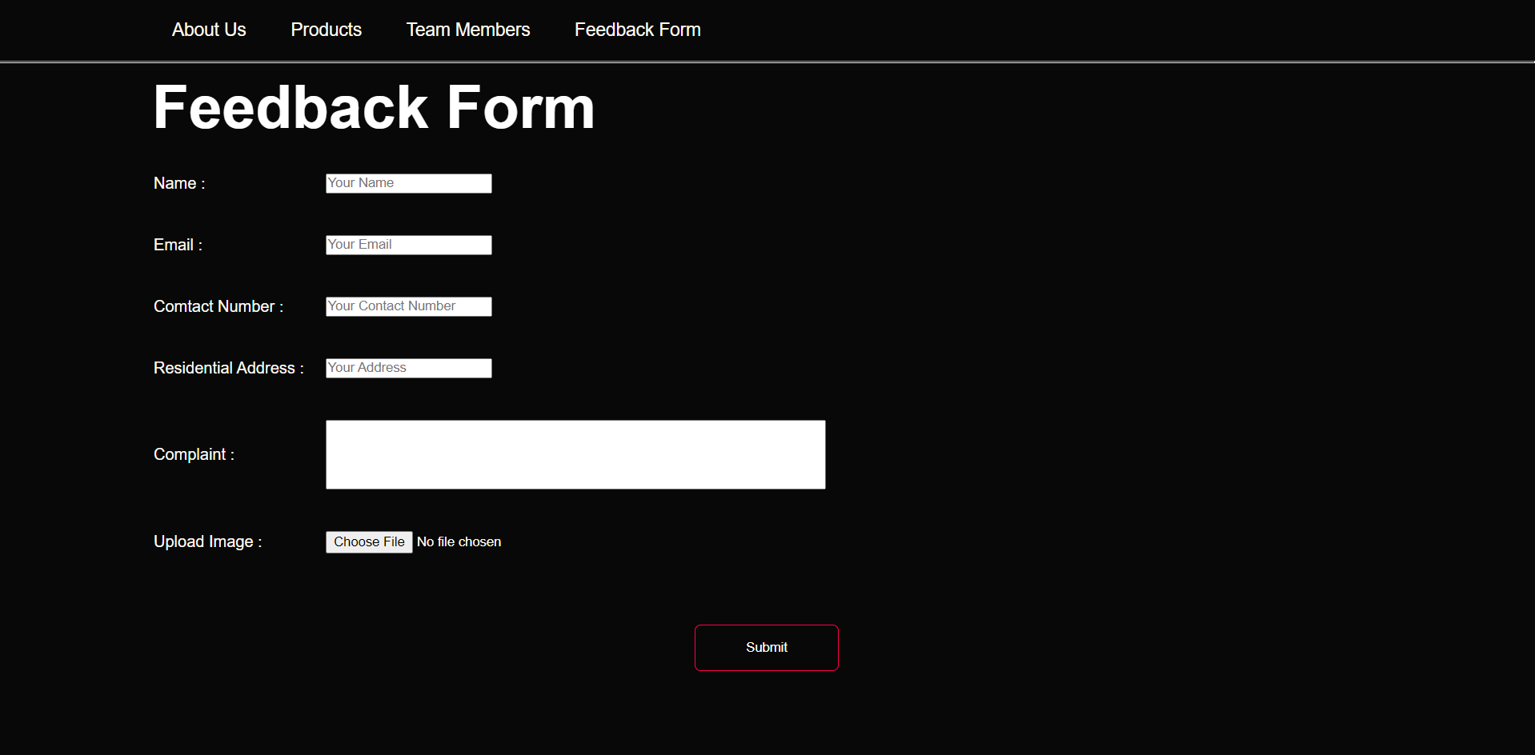

[**https://pushkarr999.github.io/Form/**](https://pushkarr999.github.io/Form/)

**Conclusion :**

* We can add validation to the input fields using javascript.
* We have to specify the source of javascript file to link html with javascript code.
* We can create form using form tags and specify the action and also send the form data to any database.